In this lesson we will see how to create react native app
We will write some code and bring some change to it by replacnig the old code with bnew code s
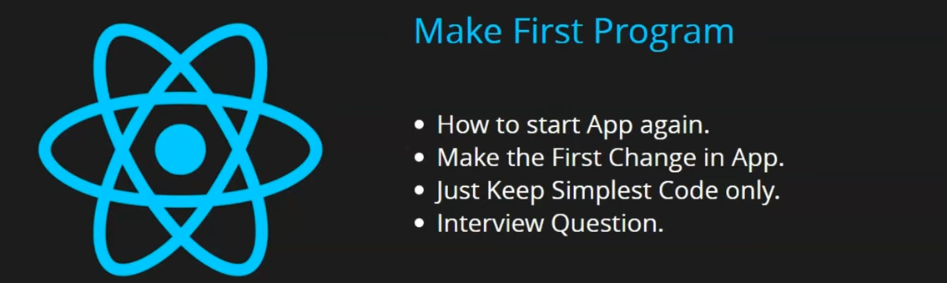
It will help you to gain confidence
we will know after doing everything to run our app and develop it and closing it how to restart it all(starting the app again)(I don't know)
We will make the first changes in our app.
We will keep the code simple and remove all the extra code to keep the app simple
by this you will get the confidence that's how we can build our small simple app.
At last Teacher will ask some important interview questions.
You don't need to open Android studio to open emulator to open your app
just run the cammand "npm run android" in cmd.
and then your emulator will be opened without having to open android studio and run it seperately.
We will just edit the app.tsx file as shown below so we just remove the file explorer.
Note:-

Once the app runs one time then the environment is set up perfectly now if you create new peoject or run this project next time then there will be no problem

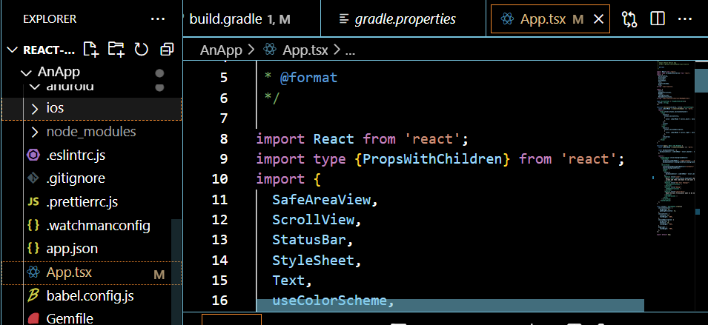
The whole project structure you will see here we will learn about it in the next lessons
you will see what file is used for what purposes
For now we are workig in app.tsx(suppose it is app.jsx)
Note:-
When the app run in phone or maybe emulator it start binding and then starts the game(I don't know).
Once the app runs in your system then after it environment has succesfully set up
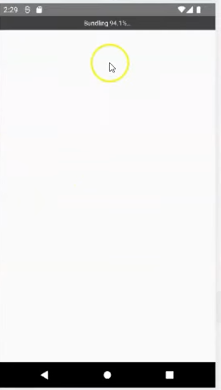
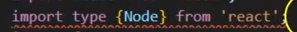
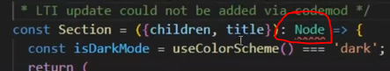
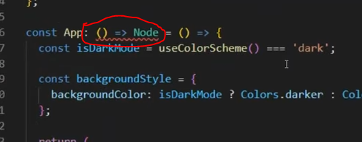
If in your App.jsx there is a line as above in top then remove it as it is used in typescript and we are not using javascript.
Remove the Node word anywhere in that file.
Make file App.jsx simple by removing the tag in return and remove the unnecessary things in the file App.tsx.
______________________________________
Note:-
Your UI or app may crash while editing the file associated with app(sometimes it happen according to the teacher(I don't know))
______________________________________
As I have studied react there will be tags used in the return of the function
So In react native we have tag called View tag
It is similar to body tag in html
Unlike react we cannot use html elements in react native
Here you need to use component inplace of html elements
Inside View Tag you cannot use
You can use <></> in place of View Tag
Inside View tag you can place internal tags we have another tag to write structures text called Text tag.
To use view and Text component we need to import it from React native.
So we write code below

import React from 'react';
import {
Text,
View,
} from 'react-native';

function App(): React.JSX.Element {

return (
<View>
<Text>Hello React Native</Text>
</View>
);
}

export default App;

Now our output will be
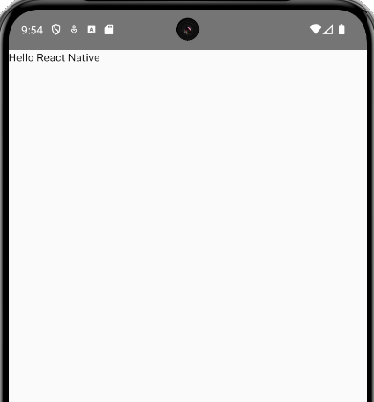

But one thing is similar that is style attribute
but this style attribute is valid for some Text like in Text tag(who knows)
Now we will increase its font and write some text of the same fontSize
Now our code look like below
import React from 'react';
import {
Text,
View,
} from 'react-native';

function App(): React.JSX.Element {

return (
<View>
<Text style={{fontSize:30}}>Hello React Native</Text>
<Text style={{fontSize:30}}>Like</Text>
<Text style={{fontSize:30}}>Share</Text>
<Text style={{fontSize:30}}>Subscribe</Text>
</View>
);
}

export default App;

Output:-
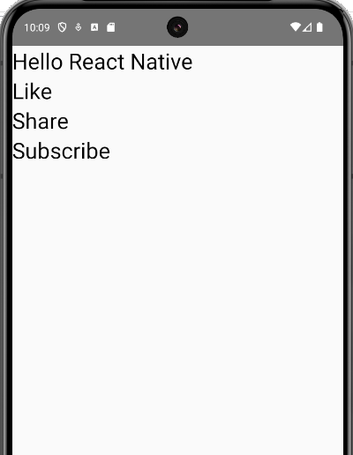

__________________________________________
Note:-
1. If there is some error occured in your app its detail will be seen in the output screen or in cmd.
2. React native is actually a framework
3. We can also include CSS in our React Native
__________________________________________
We will see the whole structure of react native project in upcoming chapter.
We will also remove the the files which we will not need

Interview Question:-
What is the difference between React and React native

In next lesson we will see the architecture of our project and we will see what file is used for what work.
We see in future How to make a component and How to use states an props. We will see all of these one by one.
The difference between a framework and a library lies primarily in the way they are used in software development and how they structure the flow of a program. And then see how to make a component , How to use states, props We will see everything
Difference between a library and a FrameWork

1. Inversion of Control:
- Framework:
  - In a framework, the framework controls the flow of the application. You write specific pieces of code that fit into the framework’s structure, but the framework dictates how and when those pieces of code are executed.
  - It's sometimes described as "Hollywood Principle" — "Don't call us, we'll call you."
- Library:
  - In a library, you control the flow. You choose when and where to call the functions or features of the library in your application.
  - You are in charge of integrating the library into your program.

2. Usage:
- Framework:
  - A framework typically provides a full structure for your application, offering a skeleton with pre-defined ways to build your software. This includes things like pre-configured workflows, templates, or even entire architecture for a web app, game, or mobile app.
  - Example: Angular (JavaScript framework), Django (Python framework), Spring (Java framework).
- Library:
  - A library is more focused and provides a set of tools or functions to accomplish specific tasks without enforcing a structure. It is up to the developer to integrate the library within their application as needed.
  - Example: jQuery (JavaScript library), NumPy (Python library), OpenCV (computer vision library).

3. Flexibility:
- Framework:
  - Frameworks tend to be more opinionated, meaning they come with pre-decided rules, guidelines, and patterns that developers must follow. This reduces flexibility but improves consistency and structure.
- Library:
  - Libraries are generally more flexible. You can pick and choose how to use them in your project. They offer solutions to specific problems without imposing rules on your application architecture.

4. Size:
- Framework:
  - Frameworks are usually larger because they include tools, conventions, and structures designed to help build entire applications.
- Library:
  - Libraries are generally smaller, focused on specific tasks, and often can be used in various different frameworks or applications.

5. Examples:
- Framework:
  - Angular (JavaScript web framework), Django (Python web framework), Spring (Java enterprise framework).
- Library:
  - React (JavaScript library for building user interfaces), Lodash (JavaScript utility library), Matplotlib (Python plotting library).

Summary:
- Framework: A complete, structured environment where the framework controls the flow of the program. It's an all-encompassing solution for building an application.
- Library: A set of reusable, focused tools or functions that you integrate into your application as needed. You control the flow of the program.
In short, a framework dictates the architecture of your application, while a library gives you tools that you can use as needed without enforcing specific structures.

